Name: _________________________________________ Date: ___________________________ Class: ______ Free Educational Materials Online www.STUDENTHANDOUTS.com The Punic Wars – Quiz
- The Roman general _____ is famous for defeating Hannibal during the Second Punic War. a. Brutus b. Hasdrubal c. Julius Caesar d. Scipio
- Who was the father of Hannibal Barca? A. Hasdrubal b. Hamilcar c. Hanno the Great d. Scipio

3. 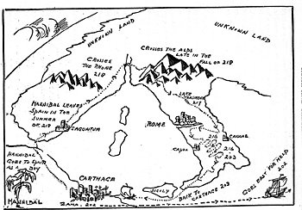
Reference the Map above
Hannibal Barca led his men, horses, and elephants on an almost unbelievably difficult journey in order to attack Rome from the north. On his way he crosses two mighty mountain ranges. A. Rocky and Blue B. Pyrenees and Alps C. Himalayas and Hindu Kush D. Alps and Atlas
4. What city did Hannibal attack to start the Second Punic War? A. Trebbia B. Canne C. Saguntum D. Trasimeme
5. Carthage’s advantage was in its _____. a. army b. democratic laws c. government d. navy
6. What land did Rome gain at the end of the First Punic war? A. Sicily B. Sardinia C. Corsica D. All of the above.
7. Carthage was located near present-day _____. a. Alexandria, Egypt b. Barcelona, Spain c. Marseilles, France d. Tunis, Tunisia
8. Hannibal suffered his first and only defeat at the Battle of _____ (202 B.C.E.). a. Actium b. Cannae c. Thermopylae d. Zama
9. Roman government: a. democracy b. monarchy c. oligarchy d. republic
10. What land did Rome gain at the end of the Second Punic War? A. Gaul B. Germania C. Spain D. Crete
11. During the _____ Punic War, Hannibal led 60,000 men and dozens of elephants from Spain to Italy. a. 1 st b. 2 nd c. 3 rd d. 4 th
12. What Geographical feature was supposed to protect Rome from invasion? a. The Mediterranean Sea b. Sicily c. The Rubicon River d. The Alps
13. What is the Roman term for Carthage or people from Carthage? a. African b. Barbarian c. Punic d. Invaders
14. Carthage’s army was superior or inferior to Rome’s? 5
15. The Second Punic War (218-201 B.C.E.) was fought over _____. a. Carthage b. Gaul c. Sicily d. Spain 16. Rome’s new weapon, the _____, forced ship crews to fight one another on deck by lashing ships together. a. anchor b. fleet c. grappling hook d. trireme
17. The First Punic War (264-241 B.C.E.) was fought over _____. a. Carthage b. Gaul c. Sicily d. Spain
18. What was the result of the 3rd Punic War? A. Carthage was destroyed B. Rome was destroyed C. Hispania was Destroyed D. Greece was destroyed

